Design Pattern Report

Proxy (structural pattern)

Motivation: Sometimes we need the ability to control the access to an object. For example if we need to use only a few methods of some costly objects we'll initialize those objects when we need them entirely. Until that point we can use some light objects exposing the same interface as the heavy objects. These light objects are called proxies and they will instantiate those heavy objects when they are really need and by then we'll use some light objects instead.

* **Intent** : provide a Placeholder for an object to control references to it.

**Description**

Proxy pattern provides a placeholder, which is representative for an object, to control access to that object.

**Example**

RMIT has a local proxy which works as an Internet Service Provider to provide access to RMIT websites for the university’s students. This proxy also records access to resources of each studentin order to maintain security.

If there is a connection to external website that is not supported by RMIT Proxy, the proxy will get that website from the real Internet Service Provider.

**Diagram**

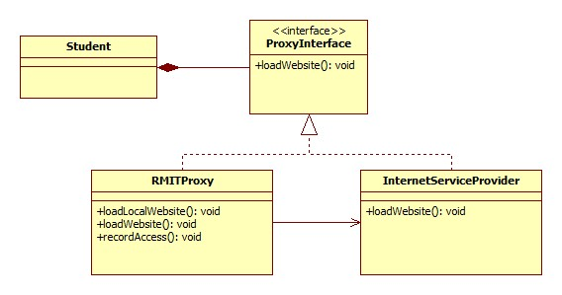

**Advantages**

Proxy pattern is useful when there are difficulties in creating connection to the real object. For example: the connection is delayed, broken or expensive.

The proxy object is customizable, which means users can define their own proxy to meet their requirements.

**Disadvantages**

Domain knowledge is required. In order to construct their own proxy, users are required to understand how the real object works.

Customized proxy and changing access between proxy and the real object could result in complicated source codes.

**Alternate pattern/Why it is a better choice**

* **Adapter Design Pattern** - The adapter implements a different interface to the object it adapts where a proxy implements the same interface as its subject.
* **Decorator Design Pattern** - A decorator implementation can be the same as the proxy however a decorator adds responsibilities to an object while a proxy controls access to it.

Strategy pattern ???